Annex N

SPECIAL OPERATIONS

Chapter C-3 OPERATIONS

- Purpose. This Annex provides information concerning the Special Operation Forces (SOF) cell within the Command Operations Center (COC) in the CTF HQs. Its primary function is integrating SOF operations into the Commander CTF (CCTF) overall plan of operations within the CTF AO.

- CTF Special Operations Overview. SOF provide the CTF with a range of specialized military responses that lessen political liability or risk. SOF can provide specific assistance in the area of assessment, liaison, and training of host country forces within the CTF AO. The operational aim is to ensure SOF supports the CTF Commander’s intent and guidance in achieving the CTF mission and at the same time, ensure SOF are integrated with the other major CTF operational functions of Land, Air, and Maritime forces.

- Special Operations responsibility will be normally assigned to a Commander SOF Task Force (CSOFTF) within the CTF command structure. The Task Force may be made up of one nation or multiple nations SOF, depending on the situation and the interoperability factors of the nations involved.

- The CCTF will normally assign an Area of Operations (AO) to the CSOFTF, based upon the CTF concept of the operation. This AO may be for a specific time frame for specific area objective areas or very narrow geographical areas for recon / strike opns.

- The CCTF will also establish Supported and Supporting relationships between the SOF TF and other CTF components (Land Component, Air Component, and Maritime Component) based upon mission requirements, to assist in prioritizing actions, assist in establishing the CTF main effort, and establish formal command/coordination channels between the components for a specific operation/mission or phase.

- SOF operations add a special dimension for influencing the crisis situation. On the lower end of MOOTW / SSC missions SOF personnel (due to their language and area specialist focus) can greatly assist in liaison and coordination with host nation personnel, civilians, factions within the country, and other missions such as reconnaissance of areas / area assessments of the situation on the ground. At the higher end of MOOTW / SSC missions, traditional SOF capabilities integrated with other component capabilities can greatly enhance mission accomplishment.

- A key aspect of Special Operations will be sustainability with in the CTF AO. SOF provide the following SOF Command capabilities to the CCTF:

  - Direct Action
  - Special Reconnaissance
  - Foreign Internal Defense
  - Unconventional Warefare
  - Combating Terrorism
  - Psychological Operations
  - Civil Affairs
  - Counter proliferation of Weapons of Mass Destruction
  - Information Operations

- Responsibilities.

- SOF Cell. Performs those duties and responsibilities as directed by the C3 and under the supervision of the COC Chief. The SOF cell is normally an integral part of the COC Watch Officer organization.

- Chief COC. The Chief, COC is responsible for the integration of all operations into the CCTF mission.

- Maintain overview of CTF SOF operations.
- Supervise the Watch Officer organization/operation.
- Advise the C3 on SOF operations.
- Develop SOF operational and contingency plans.
- Execute CTF SOF operations.
- Maintain understanding of future planning direction for SOF operations.
- Coordinate SOF operations between components and supporting organizations.

3. Deputy Chief, COC. The Deputy COC Chief is the COC Chief’s primary assistant.

- Assume duties of the Chief during periods COC Chief’s absence.
- Responsible for day-to-day operations of the COC.
- Supervise activities of Watch Officers.
- Prepare and coordinate daily and shift change briefings, etc.
- Monitors the Commander, CTF daily SITREP to ensure timely and accurate submission.

4. SOF Officer in Charge (OIC). The SOF OIC ensures the COC Chief is current on status of all ongoing SOF operations. Supervises SOF Watch Officers to:

- Monitor situation, locations, status and actions of all SOF in the CTF AO.
- Maintain a SOF events log for each 24 operational period.
- Prepare daily SOF situational reports.
- Ensure communication with all SOF operating within the CTF AO.
- Prepare operational plans and orders for SOF, as directed by the Chief, COC.
- Coordinate with Land, Air, and Maritime Watch Officers.

(continued on the next page)

- Organization. The actual organization and manning requirements will be tailored and refined to meet the specific mission of the CTF Commander, functioning under a 24 Hour Watch Officer organizational system. .
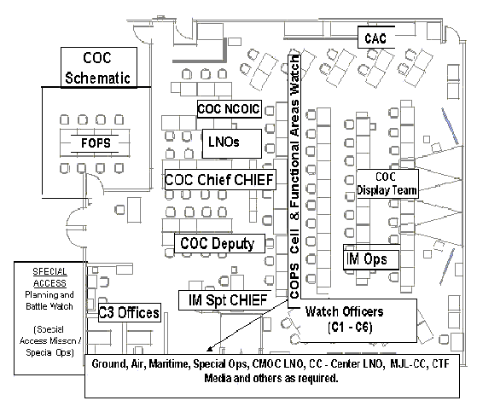
- The SOF Cell performs the following functions:
- Monitor situation, locations, status and actions of SOF in the CTF AO.
- Maintain a SOF events log for each 24 operational period.
- Prepare daily SOF situational reports.
- Ensure communication with all Cooperating within the CTF AO.
- Prepare operational plans and orders for SOF as directed by the Chief, COC.
- Coordinates with Land, Air, and Maritime Watch Officers.

- Tasks, functions, and procedures. Provides supervision, control and coordination for all SOF operating in the CTF AO. Develops plans and orders for the CSOFTF to perform assigned missions and tasks.

- Maintain continuous picture of ongoing Special Operations.

- Establish/maintain communication with all SOF operating in the CTF AO.
- Prepare required reports information,e.g. Situational Reports, Dailey Reports.
- Maintain SOF situational map.

- Prepare Plans and Orders.

- Prepare plans to support future operations.
- Prepare and implement orders for SOF.
- Coordinate with related shift leaders.
- Prepare Briefings.

  - Prepare SOF portion to daily briefings.
  - Present SOF situational briefings, as required.

- Maintain Ongoing Coordination with Land, Air, and Maritime.

- Standing Operating Procedures.

- The SOF cell will cover all aspects of coordinating SOF in the CTF AO.
- The SOF cell will be the focal point for all incoming/outgoing information on SOF operating in the CTF AO.

Considerations.

- Threat environment.
- Force structure and composition.
- Current plans, annexes, operating instructions, requirements—adaptation of future plans coordination to current operations.
- Technical and logistic support—Automated Data Processing (ADP) support, communications equipment, administration supply, and security.

- Planning Rhythm. See Part B of the SOP overview. The SOF Cell within the COC will maintain a planning rhythm that is supportive of the CTF Battle Rhythm.

- Checklists. None.

- Reports. As established by the COC Chief and CTF reports matrix.

- References.

      - Joint Pub 3-16, Joint Doctrine for Multinational Operations, dtd 5 April 2000.

      - Coalition Operations Handbook, dtd 1 Nov 2001. Produced by the American-British-Canadian-Australian (ABCA) Program.

