Annex K

AIR OPERATIONS

Chapter C-3 OPERATIONS

- Purpose. This Annex provides information concerning the operation of the Air Operations Cell within the Command Operations Center (COC) in the CTF HQs. The primary purpose of this cell is to integrate air operations into the overall plan of operations..

- CTF Air Operations Overview. The operational aim is to ensure that air operations support the CTF Commander intent and guidance in achieving the CTF mission and at the same time, ensure air operations are integrated with the other major CTF operational functions of maritime, land, and SOF.

  - Air operation responsibility will be normally assigned to a Coalition Force Air Component Commander (CFACC), to control the capabilities of coalition air operations. CFACC responsibilities include the planning, coordinating, allocating, and tasking of air operational assets based of the CTF overall concept of operation.

  - The CCTF normally gives authority with a Component or TF Commander to carry out the duties of the airspace control authority (ACA) and air defense commander (ADC). The CFACC is normally appointed (Triple Hatted) the ACA and ADC.

  - The CCTF will also establish Supported and Supporting relationships between the CFACC or TF and other CTF components (Maritime Component, Land Component, and SOF Component) based upon CTF mission requirements, to assist in prioritizing actions and to establish formal command / coordination channels between the components for a specific operation / mission or phase.

  - Air operations will be an integral part of CTF operations within the scope of the SOP because in the majority of MOOTW / SSC missions, control of air space is an absolute to ensure freedom of movement within the CTF AO (operational warfare support (if required), logistical support, and transportation support).

  - A key aspect of Air Operations will be sustainability. The following factors will be dominant in the sustainability of Air Operations:

    - Available Air Frames (Fixed and Rotary)
    - Landing Fields / Air Base Support Infrastructure
    - Weather
    - Maintenance
    - Supply
    - Storage Facilities
    - Transportation
    - Technical Support and Requirements
    - Common Sourcing of Support
    - Secure Lines of Communications (LOCs)

      - Air Operations provides the CCTF with operational reach within the CTF AO. The CCTF can execute "deep operations" rapidly, striking at decisive points and attacking centers of gravity. Further, in MOOTW operations, transportation and support requirements can be greatly extended over the CTF AO in response to emerging crisis and operational needs. Air Operations provides the CCTF the ablility to influence all areas of the CTF AO; however, detailed planning and close coordination with coalition partners, IO, NGOs, and host nation agencies needs to be present to prioritize limited resources (air frames / mission) while deconflicting strike operations if combat missions are initiated.

        - Responsibilities.

          - Air Operations Cell. Performs those duties and responsibilities as directed by the C3 and under the supervision of the COC Chief. The air operation cell is normally a integral part of the COC Watch Officer organization.

          - Chief COC. The Chief, COC is responsible for the integration of all operations into the The CTF Commanders mission.

            - Maintain overview of CTF air operations.
            - Supervise the Watch Officer organization/ operation.
            - Advise the C3 on air operations.
            - Develop Air operational and contingency plans.
            - Execute CTF air operations plans.
            - Maintain understanding of future planning direction for air operations.
            - Coordinate air operations between components and supporting organizations.

          - Deputy Chief, COC. The Deputy COC Chief is the COC Chief’s primary assistant.

              - Assume duties of the Chief during periods COC Chief’s absence.
              - Responsible for day-to-day operations of the COC.
              - Supervise activities of operations watch officers.
              - Prepare and coordinate daily and shift change briefings, etc..
              - Monitors the Commander, CTF dailey SITREP to ensure timely and accurate submission.

          - Air Watch Officer in Charge (OIC). The Air Watch Officer OIC ensures the COC Chief is current on status of all ongoing air operations. Supervises Watch Officers to:
            - Monitor situation, status and actions of all Air Forces in the CTF AO.
            - Maintain a air events log for each 24 operational period.
            - Prepare daily air situational reports.
            - Ensure communication with all Air Forces operating within the CTF AO.
            - Prepare operational plans and orders for Air Forces as directed by the Chief, COC.
            - Coordinate with Land, Maritime, and Special Operations Watch Officers.

              - The Air Operations Cell performs the following functions:
                - Monitor situation, locations, status and actions of all Air Forces in the CTF AO.
                - Maintain a air events log for each 24 operational period.
                - Prepare daily air situational reports.
                - Ensure communication with all Air Forces operating within the CTF AO.
                - Prepare operational plans and orders for Air Forces as directed by the Chief, COC.
                - Corrdinates with Land, Maritime, and Special Operations Watch Officers.

(continued on the next page)

        - Organization. The actual organization and manning requirements will be tailored and refined to meet the specific mission of the CTF Commander, functioning under a 24 Hour Watch Officer organizational system..

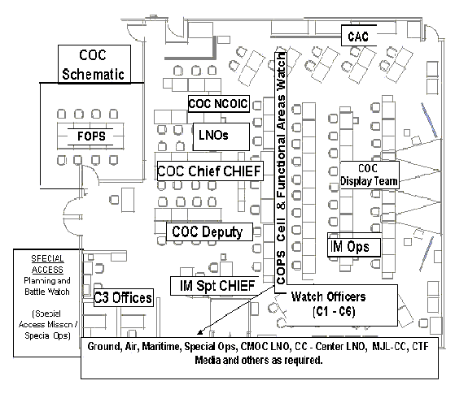

        - Tasks, functions, and procedures. Provides supervision, control and coordination for all Air Forces operating in the CTF AO. Develops plans and orders for Air Force Component Commanders of TF to perform assigned missions and tasks.

- Maintain continous picture of ongoing air operations.

- Establish/Maintain communication with all Air Force Component or TF operating in the CTF AO.
- Prepare required reports information,e.g. Situational Reports, Daily Reports.
- Mantain Air Operations situational map.

- Prepare Plans and Orders.

- Prepare plans to support future operations
- Prepare and implement orders for Air Forces Component of TF.
- Coordinate with related Watch Officer shift leaders.

- Prepare Briefings.

  - Prepare air portion to daily briefings.
  - Present situational briefings, as required.

    - Maintain Ongoing Coordination with Land, Maritime, and Special Operations Cells.

    - Standing Operating Procedures.

      - The Air Operations Cell will cover all aspects of coordinating Air Operations in the CTF AO.
      - The Air Operations Cell will be the focal point for all incoming / outgoing information on Air Forces operating in the CTF AO.

Considerations.

  - Threat environment.
  - Force structure and composition.
  - 3. Current plans, annexes, operating instructions, requirements—adaptation of future plans coordination to current operations.
  - Technical and logistic support—Automated Data Processing (ADP) support, communications equipment, administration supply, and security.

- Planning Rhythm. See Part B of the SOP overview. The Air Operations Cell within the COC will maintain a planning rhythm that is supportive of the CTF Battle Rhythm.

- Checklists.. None.

- Reports. As established by the COC Chief and CTF reports matrix.

- References.

  - Joint Pub 3-16, Joint Doctrine for Multinational Operations, dtd 5 April 2000.

  - Coalition Operations Handbook, dtd 1 Nov 2001. Produced by the American-British-Canadian-Australian (ABCA) Program.

