Chapter B-2

INITIAL NATIONAL STRATEGIC COORDINATION / CONSULTATION PHASE

(Basis for Integration of Coalition Partners)

- Introduction. As stated in the Preface and Introduction Chapter, this SOP is focused on the operational level, or the CTF level of control and coordination. However, this level does not exist by itself. An integrated framework for strategic, operational, and tactical levels of planning and execution is essential for mission accomplishment. A brief summary of the strategic coordination and consultation phase is presented in this chapter.

The chapter describes a broad overview of the initial strategic guidance that should be developed between participating nations within a MNF to support unity of effort and timely initial responses to a crisis.

The guidance presented in this chapter is broad in nature and is oriented on the essential elements CTF planners require for campaign plan and operation plan preparation. Further, this guidance (may be called a mandate in some situations) is the initial legal basis for CTF planning, operations, and integration of coalition / combined partners into the overall MNF effort.

- Legal foundations for MNF operations

#1: Multinational Regional Organization guidance based upon alliance / treaty (example: NATO, Organization of American States (OAS), or Combined Forces Command (CFC - Korea / U.S. combined command, etc.)

#2: Coalition Multinational Organizational guidance based upon crisis action situation and ad-hoc (non-treaty) actions (example: U.S., Australia, and Korea take action to relieve human suffering in a nation which requests support from these countries)

#3: UN Security Council or General Assembly resolution and mandate for multinational military operations (UN authorized or UN lead).

#4: Unilateral Operations by a single country that evolves into a coalition operation or UN operation.
Note: Immediate actions by a Multinational Regional Organization (# 1 above), Coalition Multinational Organization (#2 above), or Unilateral Operations (#4 above) may be executed without UN support initially due to the requirement for rapid initial response to address crisis action situations. In such situations, support of UN resolutions and mandates may be secured at a later date to garner international legitimacy.

- Strategic Context – There are two broad steps in the development of strategic guidance for the formation of a MNF effort and activation of a CTF command.

  - First Step – Essential Strategic Guidance Developed: The first step occurs at the national strategic level of political and military leadership. It consists of identification for the need of a multinational military effort and, in turn, development of national guidance for the MNF effort based upon consultation among the participating nations (or UN channels).

    - This first step involves the informal / formal consultation and coordination among the highest levels of national leadership for the respective nations that are involved in the potential multinational effort.

    - The end product of this coordination by the national strategic levels of leadership is called the “Essential Strategic Guidance”. This term is used within this SOP to denote the key factors that establish the initial basis for unity of effort within the CTF.

    - In all cases, the goal is to have full agreement among all participating nations for this guidance prior to execution by the CTF (or in the case of UN channels an approved UN resolution and mandate). This guidance is dynamic and undergoes continual refinement as the crisis evolves and conditions change. The eight elements of this guidance are outlined below.

    - The Lead Nation should initially address these factors to provide a sound basis for CTF planning efforts and to enable a rapid initial response to mitigate the crisis. However, lacking full guidance within all elements below (may be partially developed with missing details or parameters) should not preclude concurrent planning, coordination, and execution of an initial response by the CTF if the legal basis outlined in paragraph 1 on the previous page is present.

=========================================================================

Essential Strategic Guidance
Forming a MNF / CTF

#1: Purpose for the MNF action (Purpose for CTF Activation).

#2: Broad mission statement for the MNF (CTF).

#3: Broad objectives/tasks for the MNF (CTF).

#4: Broad criteria for termination / transition of MNF operations efforts (end states).

#5: Participating nations and the initial contributions envisioned.

#6: Lead nation for effort and the MNF SOP that will be used (see note below)

#7: Common security interests.

#8: Specific diplomatic, economic, informational, or military limitations, concerns, or sensitivities.

Note: The “Lead Nation” concept is considered to be an "Operational Start Point" for the MNF strategic level of coordination and planning structure. Along with this concept, alternatives and tailoring options for command relationships will be addressed in later sections of this SOP to resolve possible concerns concerning foreign command of their national forces.

- Second Step –Strategic and Operational Planning Levels Established / MNF Planning Process Initiated - Coalition Partner Integration. The second step is four-fold and is normally parallel in execution.

  - First, the Lead Nation will confirm the “Essential Strategic Guidance” in writing and appoint the Supported Strategic Commander. This is the military commander that the Lead Nation will pass strategic guidance through to the Commander of the CTF (CCTF). In coordination with supporting nations, the Lead Nation will also appoint the CCTF. This action establishes strategic and operational military commanders within the MNF.
  - Second, the participating nations in the MNF effort will appoint their respective Supporting Strategic Commanders. These are the military commanders that represent their respective national military within the MNF effort at the strategic level of military coordination and planning. Appointments of the “Supported Strategic Commander” and “Supporting Strategic Commanders” are pivotal in forming the strategic military framework for command, control, and coordination of MNF planning and execution processes.

Note: The terms “Supported Strategic Commander” and “Supporting Strategic Commander” are intentionally capitalized throughout this SOP because these are “specific” commanders (similar to other theater or national commanders like the U.S. Commander in Chief (CINC); Australia Chief of Defense Force (CDF); etc. Likewise,

  - Third, the Supported Strategic Commander and the Supporting Strategic Commander(s) coordinate informally and formally for the national support to the CCTF and each nation’s contribution (forces, logistics, and / or support).

Note: Countries can participate without providing military forces by providing logistics support, or support via other elements of national power (for example, through diplomatic, informational, or economic actions) that support the overall MNF effort and CTF missions.

  - Fourth, concurrent MNF and CTF planning begins” -- Coalition Integration is Initiated: With these actions, the operational level of the MNF effort (i.e. the CTF level) is formally “linked” to the strategic level (Lead Nation National Command Authorities (NCA) and the Supported Strategic Commander).

    - Liaison (LNO) teams from participating nations are deployed as required to the CTF planning location to improve interoperability and mutual understanding in the critical opening stages of the crisis and CTF activation. (Note: LNO teams may also deploy to the Supported Strategic Commander’s planning location as required).
    - The Coalition Coordination Centers (CCCs) will normally be activated at the Supported Strategic Commander’s HQs (strategic level) and at the CTF HQs (operational level). The CCCs ensure coalition operations are thoroughly integrated into the MNF / CTF planning and execution processes at the strategic and operational levels.

      - These centers facilitate strategic integration and operational level coordination of coalition forces into the planning and execution process of the MNF / CTF. These centers address the complexities of multinational coordination across the spectrum of national interagency differences, national sovereignty issues, regional nations’ bureaucratic institutions, major policy issues, national pride, historical and cultural issues, Status of Forces Agreement (SOFA) issues, diplomatic clearances, support issues, and operational employment coordination.
      - The missions for these CCCs are noted below:

    - Supported Strategic Commander CCC: Rapidly integrates coalition forces and support into the MNF command structure. Fully prepares coalition forces for hand-off to the CCTF for immediate employment).

    - CTF CCC: Rapidly integrates coalition forces into the CTF command structure. Ensures forces fully understand the CCTF’s intent / guidance, the CTF mission, their respective missions, and ensures full and active participation of coalition forces in CTF planning, and operations.

- Multinational Planning Augmentation Teams (MPATs) may deploy to augment the planning staffs of the Supported Strategic Commander and the CCTF.

- National Planning. Nations begin national planning and operational planning in support of the Lead Nation, the Supported Strategic Commander, and the CCTF.

- Shown on the following page is a depiction of the National Strategic Coordination / Consultation Phase with supporting actions at the Lead Nation level.

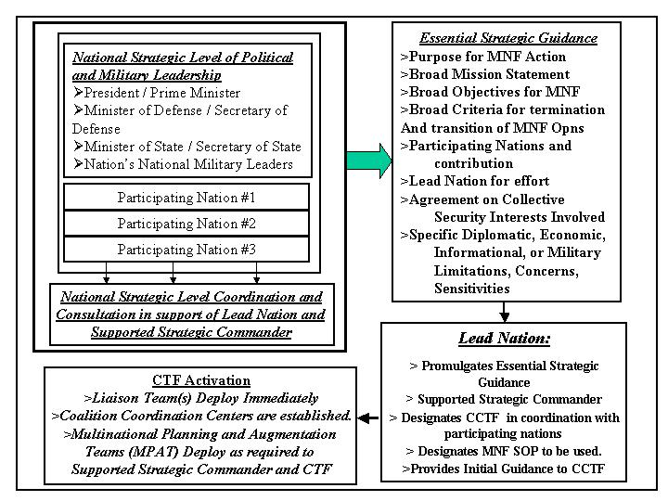
Figure B2-1: Initial National Strategic Coordination / Consultation Phase

